**CURRICULUM VITAE**

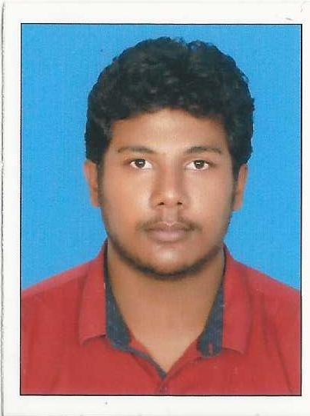

**Name:** **BIDHOV BIZAR**

**Address:** GHSS Chemnad,

Paravanadukkam PO Kasaragod– 671317.

Kerala

**Contact No:** +918848679599

**E-mail ID:** bidhovbizar@gmail.com

**Education:**

|  |  |  |  |  |
| --- | --- | --- | --- | --- |
| Degree/Qualification | Institution | Board/University | Year | Aggregate  % / CGPA |
| M. Tech  (Research) | Indian Institute of Science, Bangalore | Indian Institute of Science, Bangalore | 2018- |  |
| B. Tech  (Electronics and Communication Engineering) | Rajiv Gandhi Institute of Technology, Kottayam, Kerala | Mahatma Gandhi University (Kottayam) | 2012-2016 | 7.56 |
| 12th | Kendriya Vidyalaya No 2 , Kasaragod | CBSE | 2012 | 94 |
| 10th | Kendriya Vidyalaya No 2, Kasaragod | CBSE | 2010 | 92 |

**Internships / Trainings / Projects:**

|  |  |  |
| --- | --- | --- |
| Name of  Institution / Organization | Project Title | Duration |
| CUSAT | Gravitational Waves : Detection and estimation | February 2016  (1 week course) |
| Tropical Institute of Ecological Science | Bio Plant Automation | February to April 2016  ( 3 months project) |
| (AIYEHUM 2015 )IEEE | Blind E Book Reader | August 2014 to  March 2015 |
| TEQUIP | Intelligent Heterogenous Traffic Analyzer | August 2015 to  March 2016 |
| RIT | Spikerbox | December 2015 |
| INMO | INMO Training | December 2011  December 2012 |

**National level examination scores:**

* GATE (2018) Rank : 1276

**Subjects of Interest:**

* Signals and Systems, Communication, Machine learning, Analog Circuits

**Computer Proficiency:**

* C, C++, MATLAB

**Extra-curricular interests:**

* Playing badminton, singing, listening to music.

**Family Profile:**

|  |  |  |
| --- | --- | --- |
| Parents | Name | Designation |
| Father | Bizar A | Assistant Professor ,Lulu College of Commerce(Diseased) |
| Mother | Beena A R | Asst Teacher  GHSS Chemnad ,Kasaragod |

**Personal Details:**

Date of Birth: 08th February, 1994

Gender: Male

Languages Known: English, Malayalam ,Telugu, Tamil and Hindi

Nationality: Indian

**Declaration:**

I hereby declare that the information furnished above is true to the best of my knowledge.

Dated 13/11/18

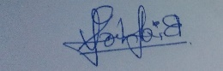

Bidhov Bizar